SECTION A: COMPREHENSION
QUESTION 1: ARTICLE
Read the article below and answer the questions that follow.
1  2  3  4 | OUT OF THIS WORLD  How would being in space, and being able to look back at the Earth, change the way you think about the Earth, its history and people, and your place in all of it?  After nearly six decades of human spaceflight, precious few people have rocketed into orbit and seen the sun peeking out from behind the Earth’s curved horizon. Since 1961, a mere 556 people have had this rarefied experience. Fewer, just 24, have watched Earth shrink in the distance, growing smaller and smaller until it was no larger than the face of a wristwatch. And only six have been completely alone behind the far side of the moon, cut off from a view of our planet as they sailed in an endlessly deep, star-studded sea.  It’s an inherently unnatural thing, spaceflight. After all, our physiology equips us specifically to succeed on this planet, not above it. Perhaps that’s why it can be difficult for astronauts to describe the experience of seeing Earth from space.  Seeing Earth from space can change a person’s worldview. The Italian astronaut, Samantha Cristoforetti, holds the record for the second longest uninterrupted spaceflight by a woman, having spent 199 days on the International Space Station in 2015. The longer she was in orbit, Cristoforetti says, the more her perception of humanity’s time on Earth was altered. When the massive geologic forces that have sculpted the planet are visible at a glance, the eons in which we crafted pyramids and skyscrapers become nearly indistinguishable. It’s as if, from her vantage point, all our constructed monuments arose overnight.  [Adapted from nationalgeographic.com, February 2018]

QUESTIONS
1.1 How many people have been to the other side of the moon? (1)
1.2 Why, do you think, is spaceflight “an unnatural thing” for humans to do? (2)
1.3 From which country does Samantha Cristoforetti come? (1)
1.4 “as they sailed in an endlessly deep, star-studded sea” (Paragraph 2).
Why, do you think, is space compared to a sea? (2)
1.5 Reread Paragraph 3.
Choose the correct answer and write only the question number, followed by the letter (A–D).
The word inherently in paragraph 3 most likely means...
A essential.
B contagious.
C desirable.
D threatening. (1)
1.6 Give an antonym for the word uninterrupted (paragraph 4). (1)
1.7 How did being in space change Samantha Cristoforetti’s view of life on earth? Explain. (2)
1.8 Write the number of people (556) who have been to space in words. (1)
[10]
QUESTION 2: CARTOON
Study the cartoon below and answer the questions that follow.
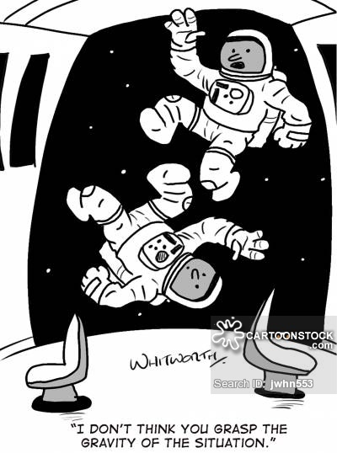

2.1 Are the words in the cartoon meant literally or figuratively? Explain your answer. (2)
2.2 Explain why we can say that the astronauts are “in a sticky situation”. (2)
2.3 Rewrite the sentence in the cartoon as an interrogative sentence. (1)
[5]
TOTAL SECTION A: 15

SECTION B: LANGUAGE IN CONTEXT
QUESTION 3: EDITING
Read the story below. It contains a number of deliberate mistakes. Correct the mistakes by answering the questions that follow. (HINT: The sentences are numbered.)
(3.1) Jason looked up at the sky. (3.2) Stars twinkled like a swarm of fireflies above his head. (3.3) Did he see it then? (3.4) and (3.5) One star was’nt stationery like the rest. (3.6) That his father said is the International Space Station. (3.7) Astronauts live there for month’s at a time to conduct experiments. (3.8) Jason decides that he will one day be an astronaut too.

3.1 Which type of noun is Jason? (1)
3.2 What part of speech is swarm of fireflies? (1)
3.3 Rewrite the question as an exclamatory sentence. (1)
3.4 Find the spelling mistake in this sentence. Write down only the correct word. (1)
3.5 Is the apostrophe correct? Say yes or no and explain your answer. (2)
3.6 Insert FOUR punctuation marks to turn this sentence into direct speech. (2)
3.7 A plural in this sentence is wrong. Write only the correct word. (1)
3.8 Change this sentence into the past tense. (1)
[10]

QUESTION 4: SENTENCE STRUCTURE
Read each of the following sentences and then answer the questions that follow.

4.1 John and Sarah (go/goes) to the soccer game every Saturday.
4.1.1 Choose the correct verb in brackets. (1)
4.1.2 Explain why the answer to 4.1.1 is the correct verb. (2)

4.2 Jemma snatches a delicious cupcake in the pantry daily.
4.2.1 Write down the verb in this sentence. (1)
4.2.2 There are two adverbs in this sentence. Which one is the adverb of frequency?
Motivate your answer. (2)
4.2.3 Write down the adjective in the sentence. (1)

4.3 The concert was out of this world, in fact i’m looking forward to the next one.
Separate the run-on sentence into two simple sentences. Use the correct punctuation. (3)
[10]
TOTAL SECTION B: 20
GRAND TOTAL: 35

